Finding even/odd using ternary operator:
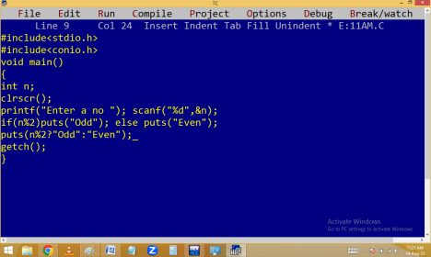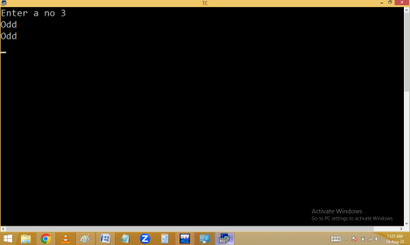
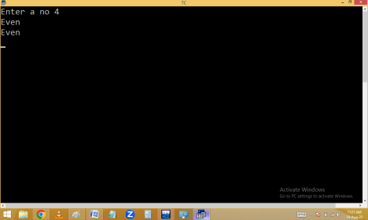Finding +Ve /-Ve /0 using ternary operator.
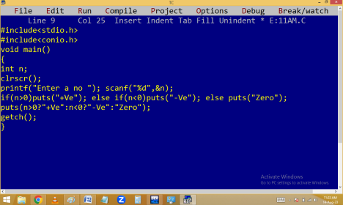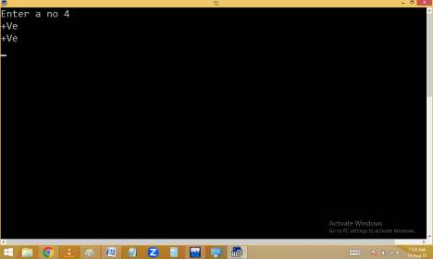
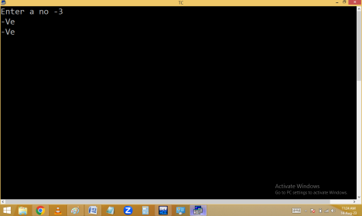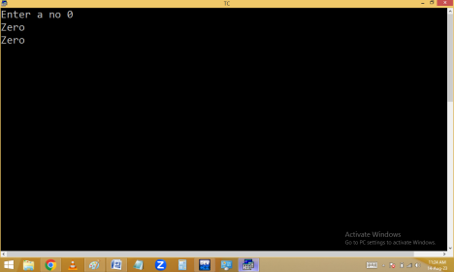
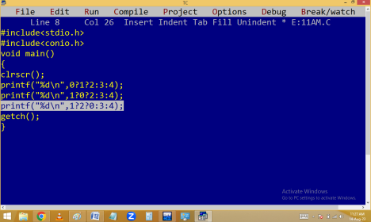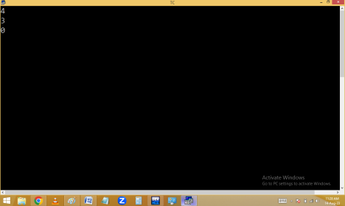
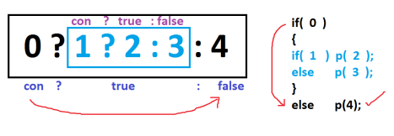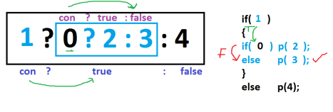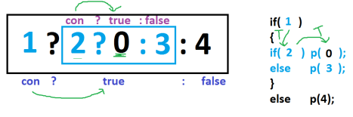
SWITCH
It is a selection statement.
It is used to execute one case of statements from no of cases according to the switch expression value matched with case expression value. In switch the program is jumped to matching case like the go to label.
It is similar to ladder if in working style.
Switch performance is high when compared with ladder if because of it jumps to matching case.
Syntax:
switch(expression)
{
case constexp1:
statements;
break;
case constexp2:
statements;
break;
case constexpN:
statements;
break;
[ default: statements; ]
}
Here switch, case, break, default are the keywords.
In between case and case expression / value at least one space should be provided. Otherwise it will become a label.
case expression/value should be a constant integer/char value. i.e. float / string not allowed.
One case contains one expression only.
case expression doesn’t contain any separators like , . etc.
case expression should be end with : (colon)
Each case should be separated with break keyword. Otherwise remaining cases also executed.
Duplicate cases not allowed.
default is similar to the else and all cases are failed then default statements are executed. Default is optional and we can declare it anywhere in our switch.
Outside case expressions not considered in switch.
